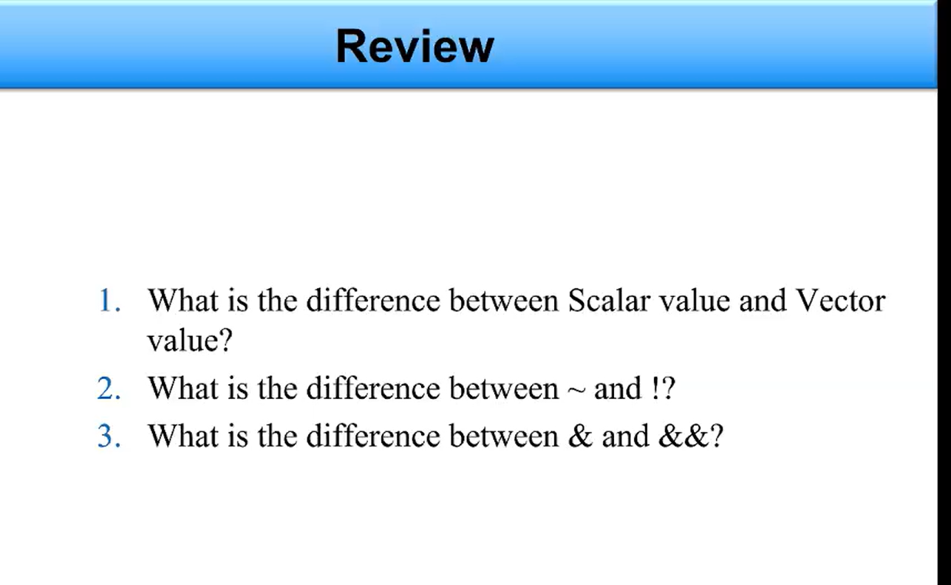
ANSWER OF 1:
Scalar is single bit value while on other hand Vector is a group of multiple bits.

ANSWER OF 2:
~ is bitwise NOT and inverts each bit individually.
! is logical NOT and gives a single true/false result.

ANSWER OF 3:
& is bitwise AND, it operates on each bit.
&& is logical AND, it operates on the whole values as true/false.

